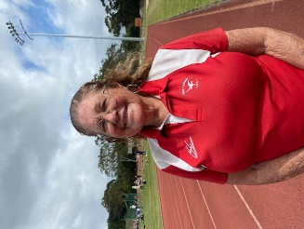
Coach profile
IAAF Kids’ Athletics Coach
Athletics Australia Level 4 Specialist Coach – Development Coach – All events
Athletics Australia Level 4 Specialist Coach – Sprints, Relays & Hurdles
Youth Aths Leader – involved with Schools programme for athletics

Merit Holder of Athletics NSW
Former National Coach for U/20 Walks
World Champs Technical Adviser to St. Moritz with Australian Walkers
Mentoring many coaches over the years
Coach to World Juniors competitors, State and National Champions, Sprints, Hurdles and racewalking
Coach to Deaf Olympics athletes

Australian Track & Field Member for over 30 years
ATFC Accredited Elite Performance Coach
Club Coach of the year NSW 1995-1996

Australian Sports Commission–Aust Strength & Conditioning Association
Level 1 Coach (approx. 15 years)

Personal Achievements
State 1 at No.1 in team for Squash
State Level Swimmer
State level athletics
A Grade Netball District
Represented Matraville High School in: swimming, athletics, netball & softball

Life Member Randwick Botany Harriers – Club Membership No: 4426
10 years Active Service/ Membership South Maroubra Surf Lifesaving Club
International Women’s Day 2006 – NSW Honor Roll
South Eastern Little Athletics Centre – Foundation Secretary
Regal Racewalkers NSW – Foundation Secretary

